# Our Commentary about the Sidewalks

Abstract

In the past few decades, in the process of economic development, people have unilaterally emphasized the pursuit of maximization of economic benefits. They have gone to Hohhot. High-polluting industries have harmed the ecosystem. As the ecosystem continues to deteriorate, people’s lives The environment has also been threatened, so the emphasis on ecosystem services has been re-emerged. So how to measure the economic and ecological service benefits of a project? This article will start from this point.

We cut into the definition of ecosystem services and selected three categories as our main research directions: Regulation service, Supply service, and Cultural service. From these three research directions, 15 indicators that can reflect the impact of an industrial project on the ecosystem are selected: carbon fixation, production of biological materials, tourism income, air purification, water supply and storage, research and cultural projects, release of oxygen, water purification, soil conservation, degradation of soil pollutants and organic matter production. These 15 indicators are usually defined by easily available natural science quantities or social science vehicles. Then we need to construct a quantitative function from the quantity of natural science and social science to the benefit of the ecosystem in terms of money. For each project, you can first obtain the relevant data values ​​of these 15 indicators, and then use our quantitative function to calculate their "ecological profit" or "ecological debt."

In the second step, we combine the economic benefits of the company to make a prediction function for corporate benefits (including ecological benefits and economic benefits), and based on the results of this prediction function, we propose to the relevant administrative department staff that we should choose projects The suggestion.

Keywords**: Ecosystem services, Shadow engineering, Predictive model**

### Contents

1. Introduction ------------------------------------------------------------------------------ 2
   1. Background
   2. Problem Restatement
2. Assumptions and Justification --------------------------------------------------------- 2
3. Notations ---------------------------------------------------------------------------------- 3
4. Model Construction --------------------------------------------------------------------- 4

4.1 Problem Analysis

4.2 Model Design

4.2 Model Solution

5. Cost-benefit model ---------------------------------------------------------------------- 11

5.1 Problem Analysis

5.2 Model Establishment

6. Model Analysis -------------------------------------------------------------------------- 13

6.1 Advantages

6.2 Disadvantages

7.A Recommendations to project planners and managers ---------------------------- 13

Reference ----------------------------------------------------------------------------------- 14

### 1 introduction

#### Background

Ecosystem services are the many and varied benefits to humans provided by the natural environment and from healthy [ecosystems](https://en.wikipedia.org/wiki/Ecosystems" \o "Ecosystems). Such ecosystems,for example, includes [agroecosystems](https://en.wikipedia.org/wiki/Agroecosystem" \o "Agroecosystem), [forest ecosystems](https://en.wikipedia.org/wiki/Forest_ecosystem" \o "Forest ecosystem), [grassland ecosystems](https://en.wikipedia.org/wiki/Grassland_ecosystem" \o "Grassland ecosystem) and [aquatic ecosystems](https://en.wikipedia.org/wiki/Aquatic_ecosystem" \o "Aquatic ecosystem).

For a long period of time in the past, people often underestimated or even ignored the existence of ecosystem services, and one-sidedly emphasized the maximization of industrial benefits. With the continuous development of industrial society, this has also led to many environmental problems. And a notable feature of these environmental problems is the weakening of ecosystem services capabilities. When people realize that the weakening of ecosystem services has threatened their rights which they thinks they are born to have, for instance, the right of breathing fresh air and drinking pure water, they began to reflect on whether they should continue to support high-yield but high-polluting industries. If not these, what industries are available for them?How to evaluate a project with ecosystem services taken into account? Is it possible to put a value on the environmental cost of land use development projects? How would environmental degradation be accounted for in these project costs?

#### 1.2 Restatement

Some high-yield projects (such as chemical plants) may cause a great environmental burden (we call it ecological debt). On the contrary, some projects that were originally considered low-yield (such as forestry or green agriculture) may have an impact on the environment. Very beneficial (we call it ecological benefits). We collectively refer to ecological debt and ecological income as ecological profit, and the former will be represented by a negative value. If we can use some indicators to quantify the ecological profit as a value in money, then we can take it into consideration together with the project income in the usual sense.

**Part I**: Find out indicators that can reflect ecological benefits;

**Part II**: Find a function that can quantify the value of this indicator as a profit in US dollars.

**Part III**: Use some realistic examples to consider the rationality of the quantization function.

**Part IV**: Use models to predict the ecological benefits and corporate benefits of different projects.

**Part V**: With the aid of the conclusion of Part IV, write a non-technical report for land use project planners and managers, and provide them with project planning advice.

### 2 Assumption and Justification

* We are able to measure the effect of a project to the ecological system with the various indicators of nature(for instance, heavy metal content in soil) which can be measured correctly. That meas the scale of the project is large enough to have an impact on the ecology; or the project has existing similar projects that can provide data for our calculations.

### 3 Notations

|  |  |
| --- | --- |
| symbol | Definition |
|  | the value of carbon sequestration |
|  | the value generated for air purification |
|  | the oxygen release value |
|  | the material supply value |
|  | providing value for gene resources |
|  | the economic value brought by the biological environment |
|  | the economic benefits brought by tourism |
|  | the amount of oxygen released |
|  | the cost of carbon dioxide afforestation |
|  | the area of the region |
|  | the pollutant conversion rate |
|  | the biomass of the plant community |
|  | the current regional oxygen release coefficient |
|  | the industrial oxygen price |
|  | the economic benefits of sediment loss |
|  | the economic benefits of land abandonment |
|  | the average annual income of the industry |
|  | the soil bulk density |
|  | the amount of land erosion |
|  | the proportion of sediment deposited in rivers and lakes to the total amount of soil erosion |
|  | average engineering cost |
|  | the volume of the polluted soil |
|  | the cost of replacing a unit volume of soil |
|  | the economic benefits of soil fertility loss |
|  | the price of nitrogen, phosphorus, and potassium |
|  | the content of nitrogen, phosphorus, and potassium in the soil |
|  | the amount of the number  product in the area |
|  | the average market price of the number  product |
|  | per unit area of gene resources for various ecosystems |
|  | the protection cost per unit area |
|  | the total area of the country |
|  | the total revenue of the country’s tourism |
|  | the cost of providing the same cultural project in other ways |
|  | The total economic benefits of ecosystem service |
|  | The total economic benefits of environmental costs |
|  | The total economic benefits of economic incomes |
|  | the water purification value |
|  | the value of water supply |
|  | the discharge volume of the jth sewage |
|  | the unit treatment cost of the j sewage |
|  | the amount of water supplied in the area |
|  | the cost of building water pipelines and other facilities |
| $I$ | the total revenue of the project |
| $C_{0}$ | the initial investment of the project |
|  | a constant that varies with the project |
| $s$ | the ecological score of that year |
| $r$ | the ecosystem recovery capacity of the current year |

### 4 Model Construction

#### 4.1 Problem Analysis

Let us now simplify the ecosystem services systems model under the general framework and divide it into two parts. The first is economic incomes, which is the real income (the difference between net income and cost) that can be obtained from land projects. The real income of the first piece can be understood through the basic information of the project. Therefore, in our model, economic incomes are directly input and do not need to be analyzed and processed by the model; the second piece is environmental costs, which refers to Pure impact on the environmental carrying capacity level. Different from the economic level, on the environmental level, different projects have different impacts, so we need to quantify the impact on the environment into economic indicators, and then use economic units to measure the ecosystem services systems. Since environmental costs involve many aspects of the environment, this part is not directly available to us, which is what our model needs to solve, so we simplified the ecosystem services systems to establish a system of environmental costs model for analysis

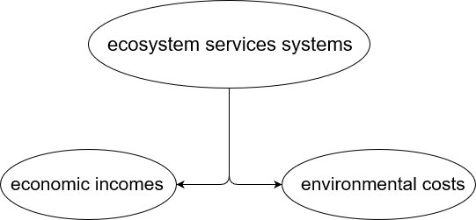

We mainly divide the requirements into four levels: (1) Select the indicator of environmental costs; (2) Prove the validity of the indicator of environmental costs; (3) Explain the quantification of the indicator of environmental costs and explain the quantitative function; (4) Combine the indicators of environmental costs and the value of economic incomes to establish a reasonable comprehensive evaluation model for ecosystem services systems.

Regarding the selection and effectiveness of the indicators, after consulting the literature and related types of project declarations, we divided the environmental costs indicators into 3 categories: regulation service, supply service, cultural service. In these three categories, we have subordinate indicators. There are carbon fixation, air purification, release of oxygen, soil conservation, degradation of soil pollutants, organic matter production, production of biological materials, water supply and storage, water purification, maintenance of the gene bank, biological control, tourism incomes, research and cultural projects, competing for these indicators, we study their overlap, correlation, and found that they do not conflict, can fully express this comprehensive evaluation system.

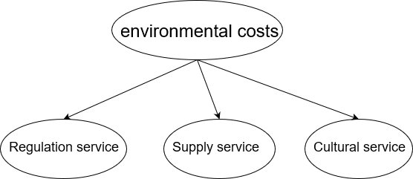

For the quantification and data acquisition of indicators, after consulting a large number of documents, we constructed different calculation value functions for each indicator to reflect the characteristics and differences of each indicator, and adopted the same dimension for direct regression. The unified processing simplifies the complexity of performing dimension normalization operations after calculating values of various indicators through functions. For data acquisition, this article attaches data samples and sources to the appendix.

Regarding the integration of indicators, in order to more directly reflect the ecosystem services systems, we will process all indicators in economic units, and directly add and subtract to express the impact on the environment and the economy, so as to reasonably establish ecosystem services. systems model.

#### 4.2 Model Design

**1.regulation service**

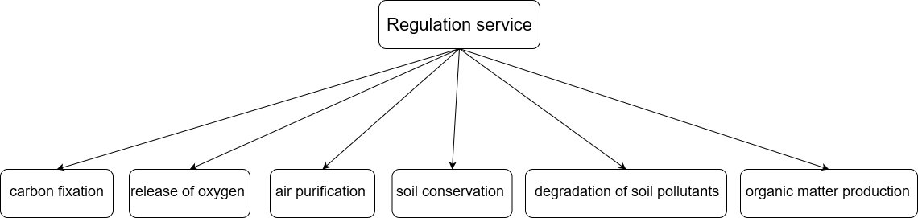

**\*Carbon fixation:**

In the ecosystem, plants photosynthesize, absorb carbon dioxide and release oxygen. Based on the calculation results of the photosynthesis formula, we can fix 1.63kg of carbon dioxide and release 1.2kg of oxygen for every 1kg of dry matter produced. According to the results of the reference [4], the afforestation cost method is used to estimate the value of fixed carbon dioxide



is the value of carbon sequestration, is the amount of oxygen released, and  is the cost of carbon dioxide afforestation

**\*air purification**

According to the reference [3], we use the exhaust gas absorption model to simplify the model we have established, adopt the value evaluation method in the literature, and take the sulfur dioxide with the most components in the exhaust gas as an example. For the carrying capacity of dust services, the smaller one is the ecological carrying capacity based on sulfur dioxide absorption, so the model can be calculated on the scale.



is the value generated for air purification, is the vegetation coverage rate, which is the area of the region, and is the pollutant conversion rate

**\*release of oxygen**

Similar to the calculation of carbon fixation value, in many regions, plants absorb and release oxygen during photosynthesis at the same time. Therefore, we refer to the reference [4], [5], [10], use the afforestation cost method, the shadow price method of industrial oxygen production, and the average value of the current industrial oxygen production to calculate the oxygen release value



is the oxygen release value, is the biomass of the plant community,is the area of the current year,is the current regional oxygen release coefficient, and is the industrial oxygen price

**\*soil conservation**

We refer to the literature [4] to establish a soil erosion model. The service benefits of soil conservation are mainly reflected in three aspects: reducing land waste, reducing sedimentation and reducing wind and sand disasters. We calculate the amount of soil erosion from reducing land The waste value and the reduction of sediment loss value are two indicators to calculate the water and soil conservation value of the water and soil use type and the total value of water and soil conservation. The amount of soil erosion is estimated by the soil loss equation USLE, which requires rainfall factors, surface cover factors, and soil erosion Calculation of the characteristics of factors, soil and water conservation measures, terrain factors and land use types

**Formula for the estimated loss value of sediment reduction:**

**Formula for reducing the value of land abandonment:**

is the economic benefits of sediment loss, is the economic benefits of land abandonment,is the average annual income of the industry, is the soil bulk density, is the amount of land erosion, andis the proportion of sediment deposited in rivers and lakes to the total amount of soil erosion, is average engineering cost

**\*degradation of soil pollutants,**

When a project is negative to the quality of the land, that is, the project will pollute the land, we take the ecological profit of the project as a negative value. Conversely, when a project is positive to the quality of the land, that is, the project will improve the local area. For the quality of the contaminated land, we take the ecological profit of the project as a positive value. We believe that the contaminated land will be replaced, so the market value method can be used to obtain the quantitative function of the project:



In which represents the volume of the polluted soil, and represent the cost of replacing a unit volume of soil. Regarding what kind of land is considered to be contaminated, we refer to many articles in agricultural science, and finally choose the standard given by Mr. Ma in the article "Comprehensive Measurement of Land Ecological Conditions in Chongqing"

**\*organic matter production**

Reducing soil fertility will indirectly lose nutrients in the soil, mainly nitrogen, phosphorus and potassium. The contents of organic matter, total nitrogen, total phosphorus, and total potassium in different soils are very different. Refer to the literature [4] and [10]. We base the loss of nitrogen, phosphorus and potassium in the area and the The amount of soil erosion in the region indirectly correlates soil fertility with the organic matter in the soil, and constructs its relationship



is the economic benefits of soil fertility loss,  is the amount of land erosion, is the price of nitrogen, phosphorus, and potassium, and is the content of nitrogen, phosphorus, and potassium in the soil

**2.supply service**

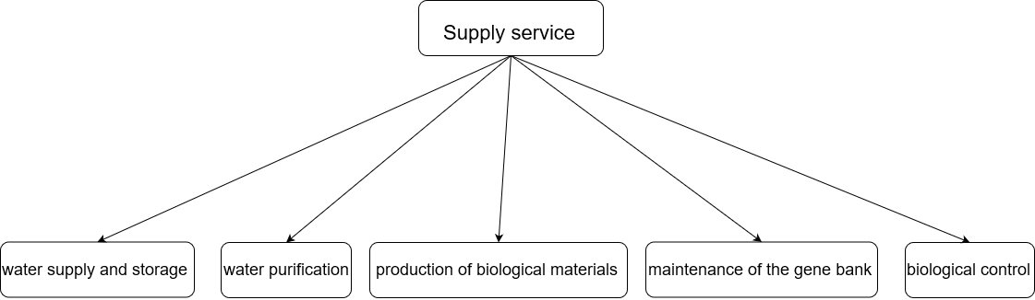

**\*production of biological materials**

Property resources are an indispensable part of measuring the value of a region, and also have a non-negligible impact on other indicators. We refer to the literature [5]. We estimate and analyze a universality based on the market value method and the result reference method. The total product resources in the area, as well as the respective relationships between economic benefits and various species



is the material supply value,is the amount of the number  product in the area, and is the average market price of the number  product

**\*water supply and storage**

The water conservation function of the ecosystem is realized by the interception, evapotranspiration, and storage of precipitation. According to the literature [5], we use the comprehensive water storage capacity method and the shadow engineering method to simplify the topographic features and optimize the model to calculate the hydrological adjustment value



is the value of water supply, is the amount of water supplied in the area, and is the cost of building water pipelines and other facilities

**\*water purification**

Water purification is an ecological process of adsorption, degradation and removal of ecosystems, as well as biological absorption and conversion of pollutants. Each water area has a biological purification function, which can decompose and eliminate various pollutants that flow into it. We refer to [5] literature, use the sewage treatment cost method to establish the relationship between water purification and economy, and calculate the value of water purification in the ecosystem



is the water purification value, is the discharge volume of the jth sewage, and is the unit treatment cost of the j sewage

**\*maintenance of the gene bank**

Gene resources are the precious wealth of mankind. Refer to the literature [1], [5], according to the results reference method and the alternative cost method, and the data provided in the literature on the value of global biodiversity services, etc. The supply value is estimated and the value provided by the ecosystem is calculated.



is providing value for gene resources, are the area of region, and values per unit area of gene resources for various ecosystems

**\*biological control**

The biological environment is also an indispensable part of the natural service process system. According to the reference [5], we use the substitution cost method to construct a simplified model to facilitate our reasonable estimation of the biological environment. The formula is as follows



is the economic value brought by the biological environment,are the area of the region, and is the protection cost per unit area

**3.cultural service**

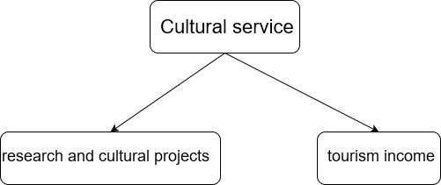

**\*tourism incomes**

According to related literature [3] and [5], we use the expense method to calculate the value of tourism. We simplify the tourism revenue model to find the proportion and use the proportion method to find the functional relationship formula



is the economic benefits brought by tourism, are the area of the region,is the total area of the country, and is the total revenue of the country’s tourism

**\*research and cultural projects**

If a project can bring aesthetic, artistic, educational, spiritual or scientific value of the ecosystem to the area, we record the quantitative benefits of scientific research and culture of the project as positive; otherwise, it is negative. It is worth noting that the aesthetic, artistic, educational, spiritual or scientific value of the ecosystem may overlap with the output of other commercial industries and materials. In order to avoid double counting, we only Record the output value provided when the project is provided for non-commercial use. After consulting a large number of documents, we finally took the method of calculating the cultural output of the ecosystem mentioned in the "The value of the world's ecosystem services and natural capital" published by Constanza in 1997 as an important basis, combined with the substitution cost method, and obtained the following Quantization function:



In which  represent the cost of providing the same cultural project in other ways.Regarding the experiments and data sources and algorithms of the ecological benefit value of different ecosystem types, there are complete documentation, calculation methods and specific results in www.nature.com.

#### 4.3 Model Solution

Because we unify the final results of all indicators in all environmental costs into economic indicators, we only need to add all the values calculated by the quantitative functions of all indicators in environmental costs to calculate the project’s environmental impact influences. If the final result is positive, it means that the project is generally beneficial to the environment and positive; if the final result is negative, the project is generally harmful to the environment and not conducive to the ecosystem service system of. We add the final result of the environmental costs model and economic incomes to get the result of the ecosystem service, to comprehensively weigh and judge whether it is reasonable to establish the project here, which not only meets the needs of the development of the ecosystem service system, but also achieves the benefits for the enterprise Maximize the benefits





**5.Cost-benefit model**

### **5.1 Problem Analysis**

In practical problems, the decision of specific projects should consider both ecological cost and enterprise income. Therefore, we set up a cost-benefit analysis model for the project from the perspective of solving practical problems. This model needs to comprehensively consider how ecological assets and enterprise income would change over time, with the changes of different projects in different locations, and provide reasonable solutions for qualitative decisions through quantitative analysis. Since ecological assets in different regions may vary greatly, in order to make the model more reasonable and concise, we differentiated ecological assets to achieve the effect of dimensionality reduction, and at the same time facilitate the quantitative calculation of enterprise income. Then, we get the function of the ecological score with respect to time and the function of the enterprise income with respect to the ecological score, which serves as the criterion for decision-making, and gives different schemes according to the actual needs of different regions.

### **5.2 Model establishment**

**Establishment of ecological score model:**

We set the value range of the ecological score from 0 to 100, and its initial value is 100. The change of the ecological score over time is mainly affected by two factors -- the ability of the ecosystem to recover itself and the ability of the enterprise to destroy the ecosystem.

For the self-resilience of the ecosystem in a given year, we consider that when the ecological score is very low, the ecosystem is severely damaged and its self-resilience is weakened. When the ecological score is very high, its resilience is similar to that when the ecological score is very low, because the ecological score is closer to the upper limit of 100. The recovery of the ecosystem was strongest near the middle of the scale.

In order to simplify the model reasonably, we assume that there is a linear relationship between the recovery ability function and the ecological score, and select 50 points as the maximum point of the self-recovery ability to construct the following recovery ability function:

$$r=10-\left|50-s\right|×0.2$$

Where, $r$ stands for the ecosystem recovery capacity of the current year, and $s$ stands for the ecological score of the current year.

The following is a score-time image of the restoration of the ecological score from zero (but not equal to zero) to 100, regardless of the damage to the ecosystem:

As for the enterprise's ability to destroy the ecosystem, we assume that the enterprise's annual ability to destroy the local system in each project is a certain value $h$.

Thus, the difference equation of ecological fraction is established:

$$s_{i}-s_{i-1}=r+h$$

Where, $s_{i}$ represents the ecological score in the I year, and $r,h$ respectively represent the recovery capacity and damage capacity in the $i$ year.

Consider restoring ability and the ability to destroy two factors influence on ecological scores, we think that the ideal model of enterprise operation is at the beginning of the damage is greater than the recovery ability, ecological scores decreased, with the decrease of the ecological scores, recovery, and eventually destroy the capacity balance, ecological scores remain unchanged in an acceptable range

**Establishment of enterprise income Model:**

We first consider the earnings of an enterprise in a certain year, and then get the total earnings of an enterprise in a certain number of years by adding them year by year, which can be used as the basis for decision making.

We believe that the income of an enterprise in a certain year is related to the ecological score of that year and the enterprise's own production capacity. The higher the ecological score in that year, the lower the level of work efficiency decline caused by ecological environmental factors, the higher the local support rate for the enterprise, and the lower the cost for the enterprise to obtain local production materials. We assume that the relationship between returns and ecological score is linear. On the other hand, we believe that the annual earnings of an enterprise based on its production capacity can be regarded as a fixed value in a certain period. Based on the above assumptions, we construct the following income function:

$$y_{i}=k\left(s_{i}-100\right)+c$$

Where, $y$ represents the income of the enterprise in the $i$ th year, $s$ represents the ecological score of that year, $k,c$ are constants, and their specific value varies with the change of the project.

For a certain project, the total revenue in $n$ years is:

$$I=\sum_{i=1}^{n}{y_{i}}-C_{0}$$

Where, $I$ represents the total revenue of the project, $C_{0}$ represents the initial investment of the project, and is a constant that varies with the project.

For specific problems, for example, a chemical plant or a forest farm is planned to be built in a certain place, and 10 years is taken as the project cycle -- we can calculate the total project revenue of building a chemical plant or a forest farm according to the above model and given conditions, and select the higher one for investment.

For specific problems, for example, local ecological protection has special requirements, we can also add the constraint condition of ecological score, stipulate the minimum value of ecological score, and then find the maximum value of objective function (total revenue) under the constraint condition.

### 6. Model Analysis

#### 6.1 Advantages

①The selection of indicators refers to many influential documents, which is convincing.

②The use of some indicators to quantify the ecological profit as a value in the unit of money can be considered together with the project income in the usual sense, which facilitates the subsequent process.

③In the forecast trend of the model, by combining the big data found and using the method of function fitting, the differential equation of the forecast function is written, which can better predict the future trend and analyze more effectively.

#### 6.2 Disadvantages

①In the selection of indicators, there are still problems such as mutual interference and overlap of indicators, and incomplete indicator selection.

②In the calculation of the model, because of the lack of some data, we can only roughly calculate the approximate interval of the data that needs to be used through the related data to find our solution. Therefore, in the solution of the model, there is The error.

③In terms of indicator detection, our quantification function has not been tested by big data, and there may be problems.

### 7.A **Recommendations to project planners and managers**

Recommendations to project planners and managers

The biosphere is the foundation for human survival. It provides the necessary natural processes for the healthy and sustainable development of human life. This process is also called ecosystem services. Ecosystem services also follow the principle of conservation of energy, and current decision-makers often ignore the impact of this measure on the biosphere when making decisions using economic theories. They often assume that the biosphere has unlimited resources for them to use. For example, Many heavy industry factories often blindly increase mining volume or arbitrarily discharge pollutants that are inevitable in their production process in order to increase their output and increase economic income, but this is often not the case. They ignore the load that the ecosystem can bear. Value, it is precisely the limitations of this wrong cognition and decision-making that have caused the hard conditions of the biosphere and ecosystem services to be severely damaged.

Green water and green mountains are golden mountains and silver mountains. The model we build conforms to the development of the times and nature. Therefore, our model will also give some opinions to managers and land planners.

1.Before resource extraction, resources should be rationally used. Conduct exploration and evaluation of the site to determine whether it is suitable for mining;

2.Before constructing factories and other buildings, it is necessary to reasonably evaluate the environmental impact to determine whether the establishment here is reasonable and whether the impact on the environment is minimized;

3.Reasonably control the discharge of pollutants, select appropriate methods and regions to deal with the unavoidable pollutants in the production process, and minimize the impact on the environment;

4.Appropriately change production methods and improve production technology to reduce pollutants Land emissions, to fundamentally reduce the impact on the biosphere environment;

5.On the basis of not affecting the country’s comprehensive development of various industries, select some relatively small environmental pollution projects to comply with the times;

6.Do conscious regular inspections, And accept the irregular supervision and control of the supervisory department in accordance with the regulations.

When everyone can consciously implement these opinions and regulations, then we will do a good job in the energy exchange in the process of ecological services, and can realize our own interests while obtaining enough materials from environmental resources. The maximization, that is, the value can be realized without destroying the environment as much as possible. Green water and green mountains are golden mountains and silver mountains. When everyone can understand the connotation of this sentence, then everyone will consciously abide by it, and the environment and us can all benefit from it.

*Your humble adviser Leo*

### Reference

* [1]‘Evaluation and Analysis of Ecosystem Service Value of Baiyangdian Wetland’, Yaqiong Xing 2017
* [2]‘Research on ecosystem Service Value evaluation of Baiyangdian Wetland’, Bing Gao 2020
* [3]‘A review of urban ecosystem services’, Qizheng Mao ,Chinese Journal of Applied Ecology, 2015.4
* [4]‘Tradeoffs and synergies of ecosystem services in Guanzhong - Tianshui Economic Zone’ , Jing Li ,ACTA ECOLOGICA SINICA, 2016.5
* [5]‘Study on ecosystem Service Value evaluation and its influencing factors of Beibu Gulf Coastal Wetland in Guangxi’ , Bin Wu , 2020
* [6]‘Evaluation of the service value of typical regional water ecosystem in the lower Hanjiang Plain’, Wen Xiong,Yangtze River, 2020.8
* [7]‘An analysis of the protection vacancy of Nature reserve in Beijing based on ecological value evaluation’, Da Feng ,Chinese Journal of Applied Ecology, 2020.5
* [8]‘Concept, connotation, evaluation model and application of ecological carrying capacity based on ecosystem services’, Zhi Cao ,JOURNAL OF NATURAL RESOURCES, 2015.1
* [9]‘Assessment of the change of ecosystem service function value in Taihu Lake in recent ten years‘, Junmei Jia ,ACTA ECOLOGICA SINICA, 2015.4
* [10]‘A preliminary study on the service function and ecological economic value of Terrestrial ecosystem in China’, Zhiyun Ouyang, ,ACTA ECOLOGICA SINICA, 1999.9